MaterialSupplyHub.com/demo

1. Can the images rotate/scroll/carousel on the main page?

All pages:

1. Scrolling is slow in Firefox; I think we checked others and it may have been fine in some but not in others; and you may have changed something to fix this once before.
2. Everything feels larger than it should be; if I reduce my browser to view at 80%, it feels better. Is it possible to reduce the UI to 80% of its current form to reduce massive what space and ‘largeness’? (if that makes sense) Funny thing is, it appears great on my Surface, but my desktop is huge.

Remove the white space on homepage header area (shown below in the red line)

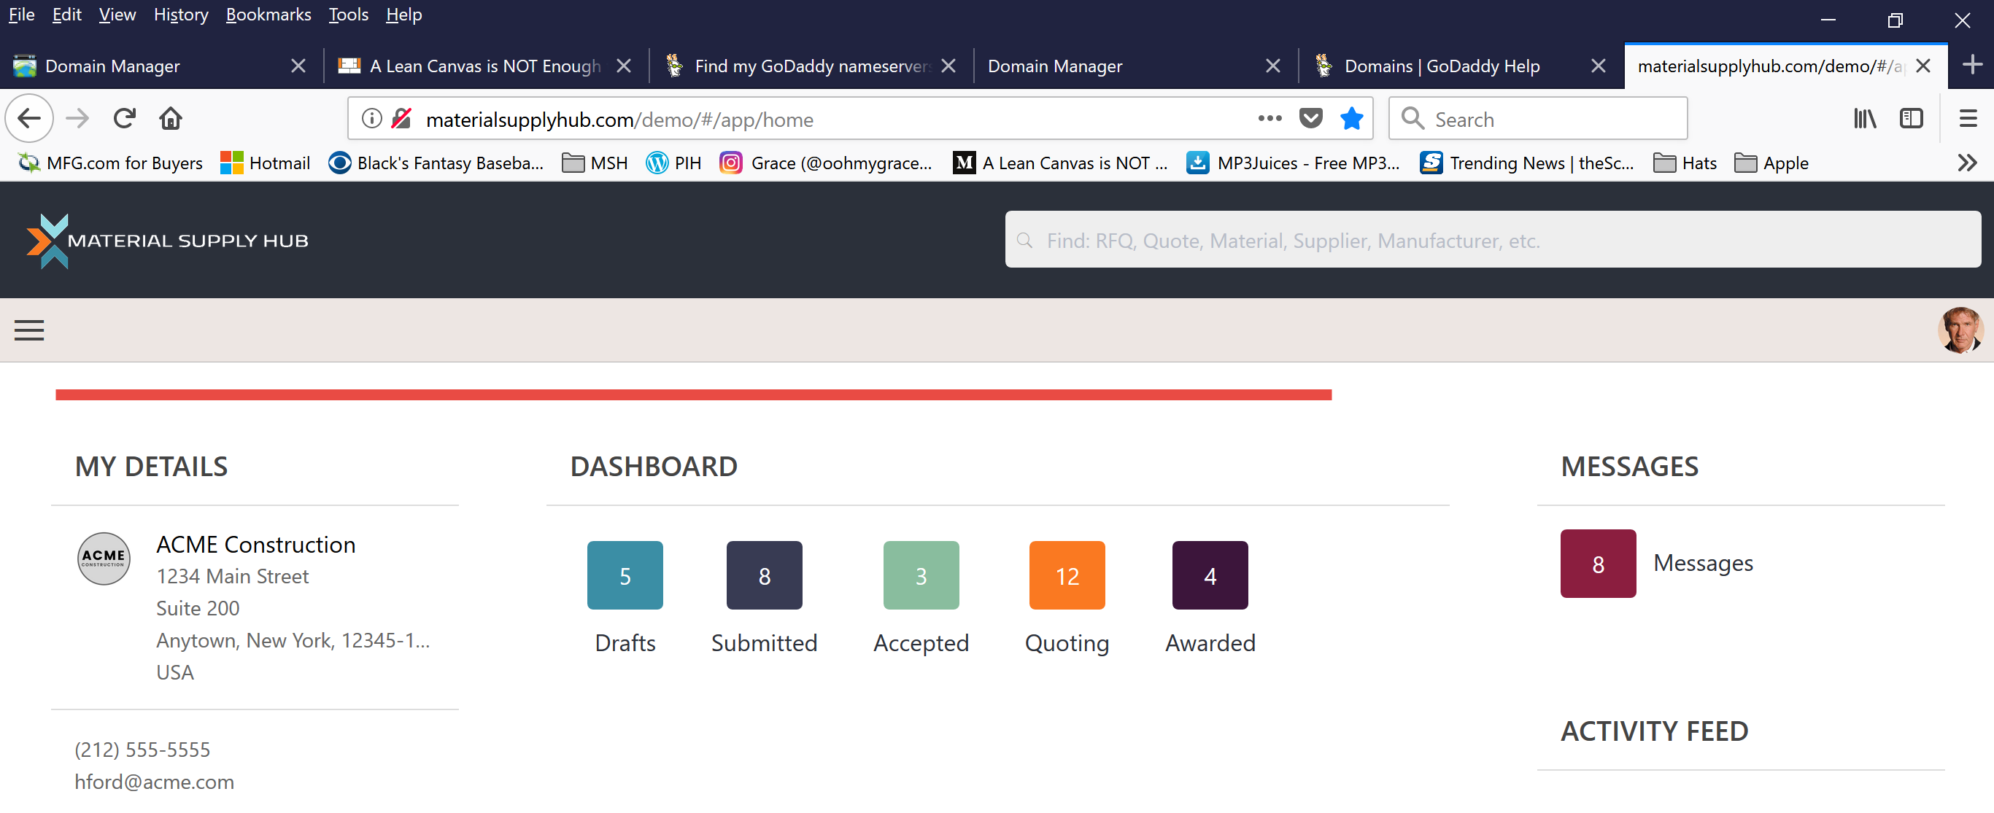

Within the “MY PROPOSALS” section, after submitting a proposal, the “status” is showing 2 proposals submitted vs. the one proposal actually submitted; we’ve seen this again and for some reason when creating a record, 2 records appear.

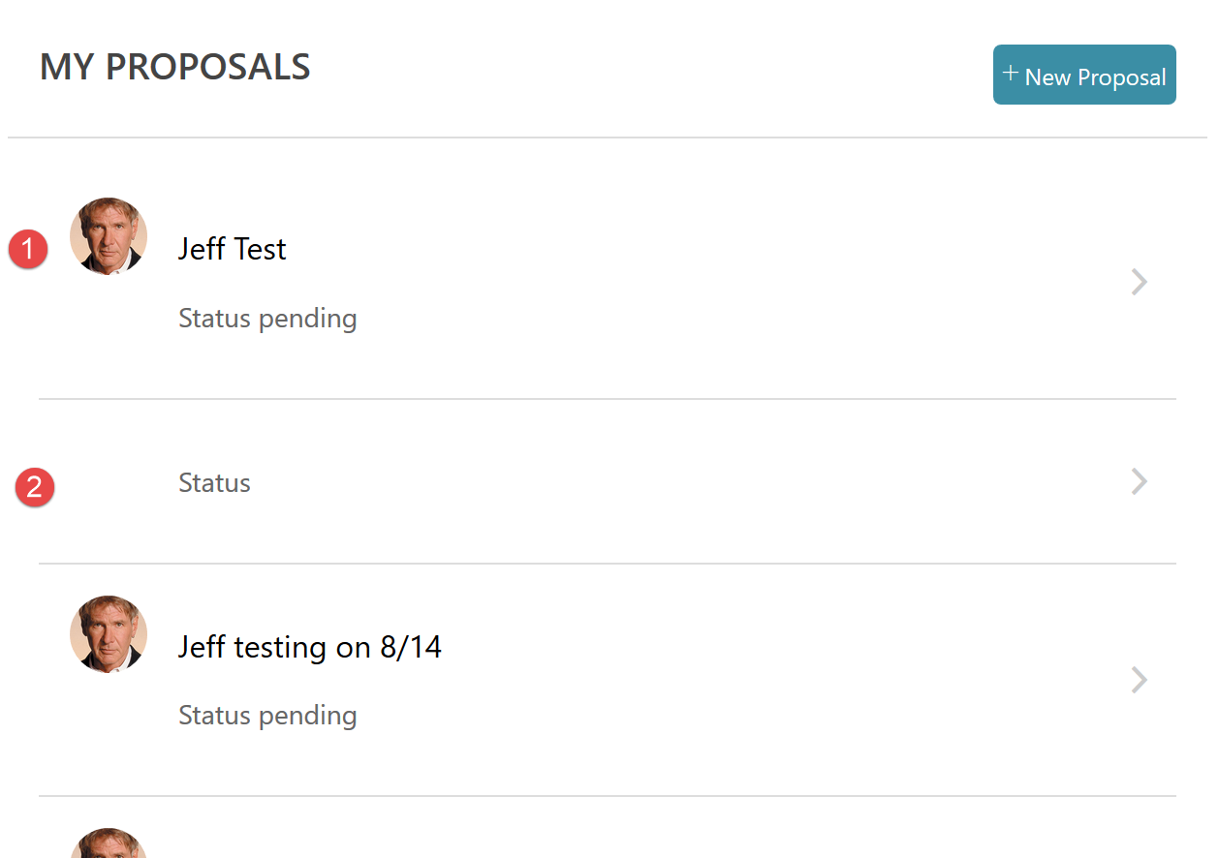

Within the “MY CAPABILITIES” section, can we make this “tighter”? Kind of goes hand in hand with the bullet 3 above. (Left side current / right side my example)

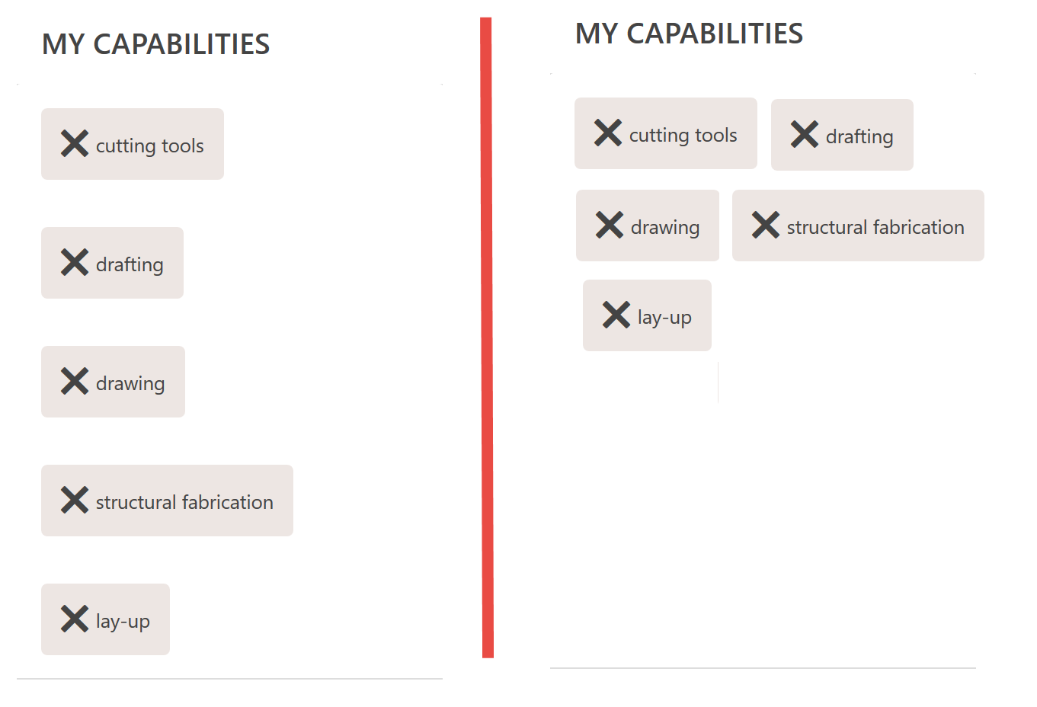

The “MY WIDGETS” section, each widget should have a better header font as the headers now got lost and just appears as text. Maybe kill “MY WIDGETS” and make each widget name a header like MY WIDGETS appears.

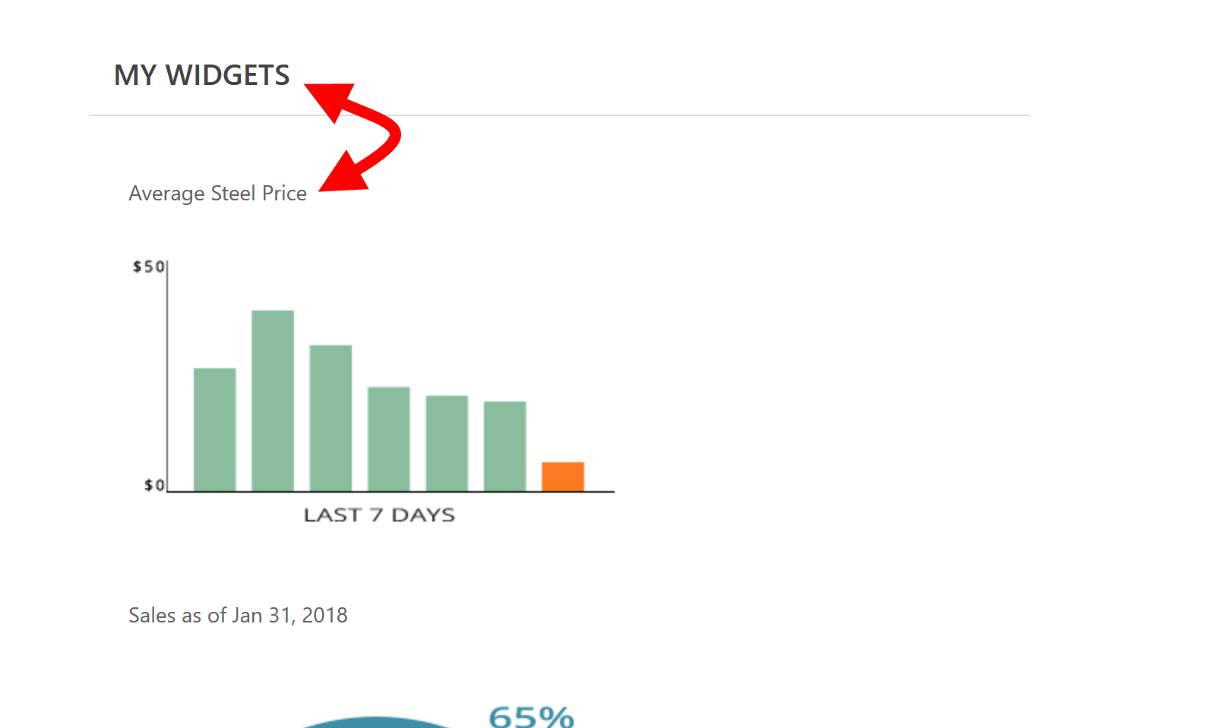

The “ACTIVITY FEED”. Is this real content or is it faked? Fine if it is fake, I think the copy displays a bit odd.

Clicking +New Proposal after submitting a proposal already brings up old content so adding a 2nd proposal was not possible. I was also seeing when doing this that the page is scrolled all the way to the bottom vs. the top of that window. (shown below)

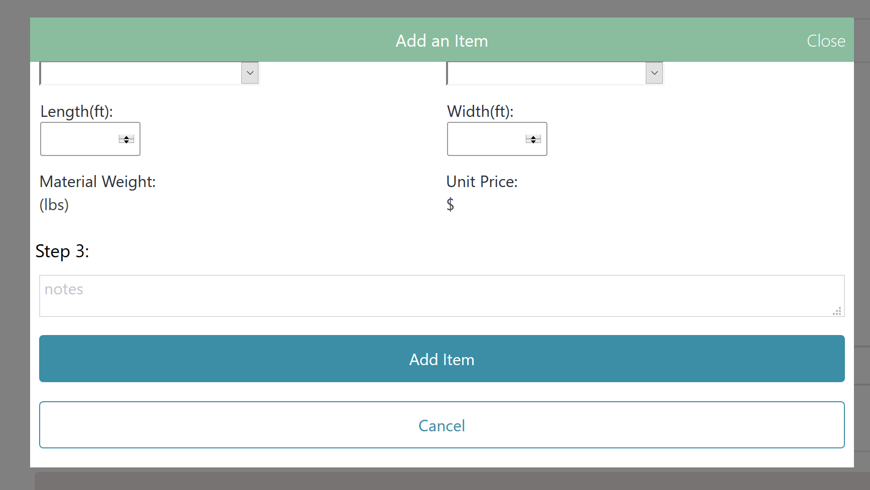

When creating a proposal, within “STEP-1”, clicking Save and Continue brings you to a page that is blank and an Add Suppliers button; Clicking Save and Continue should bring you to the "Add Materials" page

The “ADD ITEM MODAL” Mark eventually wants this as a page but we can do that later; basically he wants the page and “add items” functionality to be on a single page

The “ADD ITEM MODAL”, Reduce spacing below step-1 and above step-2; trying to get as much as possible in view. (This looks fine on Surface; desktop looks large!)

The “ADD ITEM MODAL”, Weight & Price - Is this fake calculations?

The “ADD ITEM MODAL”, Clicking Add results in the modal going away; we had talked about there being two buttons, a “Save & Continue” and a “Save & Add Another” button so the user didn't have to exit and enter repeatedly.

“ADD ITEM MODAL” – Adding 2 items, things appear fine. If I add a 3rd item, the RFQ page shows empty boxes

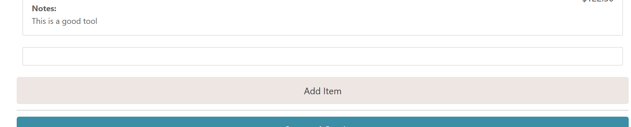

Within each material item box, where the items are listed out, rather than having the items listed vertically, list them in rows. Example:

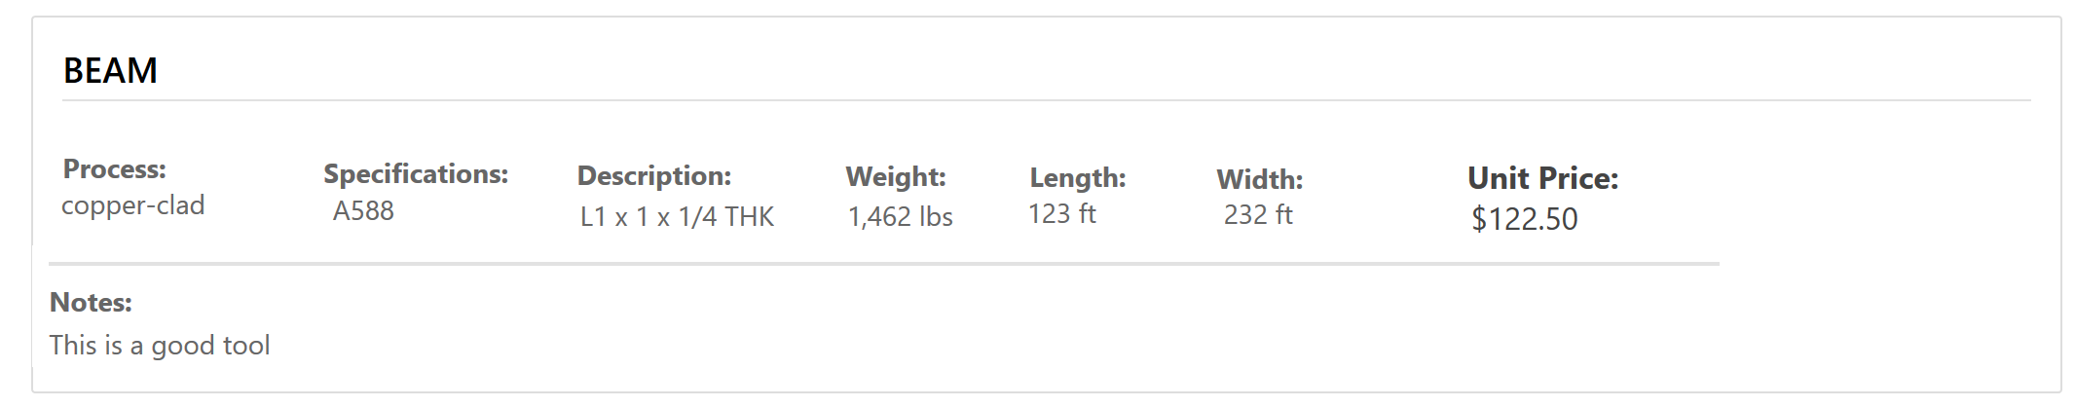

After successful submission, of an RFQ, there should be a message confirming their entry

Added suppliers don't appear